***\*\*\*\*\*NOTE**(EVERYTHING THAT HAS A FONT COLOUR BLACK GOES ON THE PPT)***

***Description:***

* ***Introduction***

The ecological preserve of Oostvaardersplassen has three large herbivores living there. They are: wild horses, wild cattle, and deer; and other foremost species such as geese and birds of prey.

* ***Problem***

The problem comes from the major factor of the ecosystem has hardly any predators and the herbivore's prohibitation of migrating.

As well the number of geese, particularly during winter, increase which causes the level of competition to increase. The interaction between the herbivores and the geese for resources can be quite severe, and can lead to extreme situations such as extinction.

Thus in consequence the Oostvaardersplassen preservation has established an unbalanced ecosystem.

* ***Purpose of the project***

The purpose for this project was to work towards a possible solution of the problem involving Oostvaardersplassen. This solution is based on mathematical model used in an application, which graphical illustrates predictions of the ecosystem.

***Project research question and sub-questions***

* ***Research question***

*Beckground info*[The main research question for the programme is going to be divided into two parts. One of the parts focuses on the relationship of the predator-prey relationship while the other focuses on the competition coefficient. For the reason, two applications are needed in order for the answer to be found.] - someone say this

Main Research Question of the project at the programme level is:

What will happen to the populations of deer, cattle, horse and geese if releasing a number of foxes in the preserve (with the number of foxes being the free variable)?

The Main Research Question for this research paper, project level, derives from the programme research question, based on the competition between the herbivores:

How do the herbivores and the geese compete for the grass in an enclosed area?

* ***Research sub-questions***

*background[*The research sub-questions are questions which derive from the main research question and provide the path to the answer of the research paper.] - someone say this

Sub-Research Questions for this research paper:

* What is the rate of grass consumption of each animal?
* How do animal populations change as a result of grass availability?
* What are the populations of each animal?
* How can the start data and historical data help shape existing mathematical models to an equation which fits the problem in Oostvaardersplassen?
* How can the application hold all the implementations that are being asked?

***Research Methodology***

*background[*The research methodology had several development phases ] - someone say this

1. [One of the phases in the research is based on ] - someone say this

**Data Collection** [This is the point at which all the information necessary to proceed with any of the further steps, was gathered. ] - someone say this

1. [ The second phase of the research then fully focus on the development of the ]-someone say this **Mathematical Models [** which are the ones who help calculate the prediction outcome of the ecosystem based on different animal population inputs.] - someone say this
2. **Software development** [is the third phase and includes multiple developments in the view, those are the frontend work as well as the backend work] - someone say this
3. [The last phase of the development is the] - someone say this

**Connection** [which will be established between the two software applications to allow information transfer. ] - someone say this

* ***Data Collection***

This phase includes information regarding: *population statistics* during different seasons, *birth rate and death rate,* the *amount of grass eaten*, and any *other related data*.

By the use of provided resources, initial information was deduced. Due to lack of information, on some of the species, similar specie data was used. However, further calculations were involved to find variables that fitted to the answer of the ecological problem.

* ***Mathematical Model***

The *equation*, used in the first mathematical model, is a *modified version*, of the competitive Lotka-Volterra model.

The *modification* made to the model was the introduction of an extra variable, G, which measures the grass availability.

This model calculates the *population growth rate* of a specific species, given the specific species’ *grass availability*, *intrinsic rate of increase*, *carrying capacity*, competing species’ population and their competition coefficients.

Eq…………………………………..

A second mathematical model was developed, to calculate the total grass consumption for each animal’s specie.[Although this variable wasn’t needed in the main mathematical model, it was required to help determine the answer to the main research question ] - someone say this

Eq…………………………………

* + ***Software Development***

The **software development** was divided into two parts the *backend work* and the *frontend work*. However the process of development began with neither but by creating *UML diagrams and models*. [This helped to visualize how the application will look like and what it should do. As soon as, the UML model for the application is completed the focus then turns to the back-end work, implemented using Java. After having the engine and the whole data of the Oostvaardersplassen in the program, the application will then be developed to display the prediction in a GUI, via using JavaFX.]- someone say this

During the development of the UML models and diagrams, important aspects based on user goals [the use case description]shaped the final *features[features list]* of the applications.  As well the behavioralset of actions[use case diagram], that the system can perform in collaboration with the external users of the system, was deduced. Then UML models and diagrams related to the backend of the development followed. The [*domain model*]conceptual classes and the relationships between them, provided an initial view of how the interaction between predicted population changes and update of the UI. The structural diagrams helped with the visualization of the connection between the applications [*sequence diagram*]. Here the process goes from data user inputs and a description of the steps of the process of handling that information to get an output, was described. By the usage of the software design pattern, descriptions and structural behaviour of the system were shown, the system's classes, their attributes, methods, and the relationships among objects.[ *Class Diagram]*

[Since the application is built dynamically in] The *front-end development*, which is the creation of the Graphical User Interface (GUI) was by utilizing Scene Builder. It consists of Menu Bar, Text Fields, Buttons, Radio Buttons and Graph, which visually represent the data.

In the *backend work*, the development of the software side, makes the prediction possible. The key aspects of the backend is to make the GUI work. One of the functionality is to take all the text fields inputs, from the GUI, process them inside the mathematical model and then to display the prediction in the GUI.

* + ***Connection***

[The last step into development is ] The **connection** between the two applications is done the use of sockets, which send JavaScript Object Notation (JSON) objects containing values used in calculating a prediction. The object will be sent, the application will wait until it receives a response from the other application, then the following year’s prediction will commence. The process of communication will be similar for both applications.

***Results***

The results of the development of the application, which results in a prediction of the ecosystem, has been developed in sequential steps which involved: **data collection**, which gathered information for the **mathematical models** to be built. Then followed by the **development of the software** was worked on which then led to a **connection**, between two applications.

* Results Data Collection

During the **data collection** session, a lot of information has been collected, which was to be further used in the development of the project.

The first results, in this research, deal with the consumption of the animals living the nature preserve. The figures with the dietary distribution in percentages, that were found out during the development of the research can be found under the List 4.1.

|  |
| --- |
| **Cattle diet** (Mcinnis, Michael L., and Martin Vavra 1987):  Graminoids 88%  Forbs (Herbaceous Plants) 3%  Shrubs (Woody plants) 8%  **Red Deer diet** (Wieren, Se Van. 1995)**:**  Graminoids 20%  Forbs (Herbaceous Plants) 24%  Ferns (Herbaceous Plants) 10%  Browses (Woody plants) 44%  **Konik Horse diet** (Cosyns, Eric, Tine Degezelle, Else Demeulenaere, and Maurice Hoffmann 2001)**:**  Graminoids 86%  Herbaceous Plants 12%  Woody plants 2%  **Geese diet** (Middleton, Beth A., and A. G. Van Der Valk 1986)**:**  Graminoids 83%  Herbaceous Plants 15%  **Other animals:**  Insects/Snails 2% |

In concordance to the website (Intake requirements n.d.), in regards to the data collection concerning with the food consumption of the *Red Deer*, it shows a distribution of a 50/50 rate of male/female dears. By means of data shown in a graph (Graph 4.1), it was deducted that the average deer weights about 110kg, and consumes about 2.5kg of Dry Matter each day.

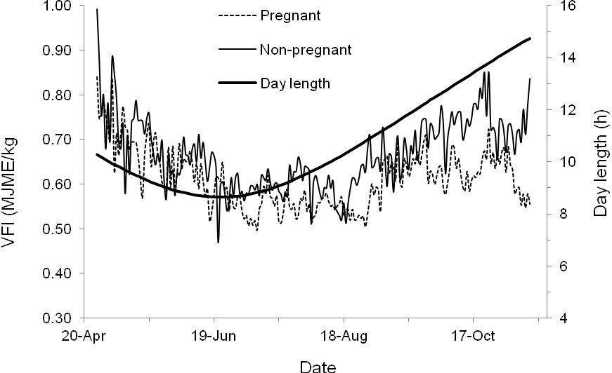

Per the website (Konik 2016), used to collect data about *Horse* food consumption, the average horse consumes every day around 2.5% of DM; depending on the horse‘s body weight. Per the source, the horses in Oostvaardersplassen weigh between 350kg-400kg, it was decided on taking an average body weight of a horse of 375kg, which consume 9.4kg of DM each day.

From the source (Cattle 2017), used to generate information about the food consumption of a *Cow*, can be deduced that the average cow consumes 2.5% of its body weight in DM each day. The average weight of a cow in Oostvaardersplassen is 600kg, which means that each cow consumes 15kg of DM on average every day.

Due to lacking information in the data collection in regards to the food consumption of a “wild *Goose*”, a farm goose was decided to be taken as a source for indication. Per the source *(E. Joyner, N. Jacobson, & D. ARTHUR, n.d.)*, the average goose consumes everyday around 0.15kg of DM.

To convert the area of DM grass in Oostvaardersplassen, it was needed to do a research of how to convert the area to weight. Calculations are made by plugging in the values into the equation found in Section 3.2 under Expression 2.2. The calculations are to be displayed under Expression 2.2.1.

The primary source (Co, n.d.), is a company who sell grass for golf clubs in pallets, where each pallet covers 450feet of the area (137.16m) and weigh 2250lbs (1020.583kg). A factor which needs to be taken into consideration that the grass height when being sold, to the customer, is at 0.3cm height. Considering that the area of DM grass in Oostvaardersplassen is 20,000 square meter, which means it is required to have 479 pallets of grass to cover all this area.

The grass at Oostvaardersplassen is at around 14cm per 2015, which means the available amount of food at Oostvaardersplassen. Expression 2.3.1 holds the calculations with the values inserted the equation, can be found in Section 3.2 under Expression 2.3.

What makes this method valid is the fact that in order to get the total yearly amount of grass consumption by each animal, the daily consumption has to be multiplied by 365 days in order to make it a total consumption per year. The reason for changing the daily consumption into a yearly consumption is because the application itself is working in years and not in days. This method is laying over the research that has been done over the food consumption of each herbivore and the geese.

The population’s amounts of the herbivores were also found, with the help of the most recent reference which was May per 2015. After some research with calculations and some small assumption, it is now known what the estimated herbivores numbers in accordance to 2016.

Per May 2015, there were 250 cattle, or cows, up to May 2016, 80 cows died. The assumption made is that there were 60 cattle born on average for the last few years. This means that there are an approximate 230 cows which are now living in Oostvaardersplassen preservation. In accordance with May 2015, the number of Konik horses was an estimate of 1250, up until May 2016. Out of which 380 horses died, and under supposition is the number of new born which is 250, on average per last few years. Thus, resulting in a population of 1120 horses living in the conservation. Lastly, the Red deer population is counted to be 3200 up to May 2016, in accordance to May 2015. The death rate indicates that 970 deer died, during the past few years. There is an estimate of 700 dears which were born average for the last few years, which means the deer population coming to a numeral of 2930 deer. The Geese are estimated at about 30,000 each year, not taking into account migration.

* Results Mathematical Model

The modified competitive Lotka-Volterra **mathematical model**, was used to develop the application for predictions in regards to future animal’s population. In order to calculate the population growth rate of a specific species, several variables had to be found. Those being: the specific species’ population, intrinsic rate of increase, carrying capacity, species’ competing populations, and their competition coefficients.

In order to check the accuracy of the formula, the group made many tests that were successful. One of the test, that was taken, was taking the figures of 1992 of the historical data and put into the application to test the outcome prediction. The figures that were used in the test prediction were: 170 cows, 45 deer, 85 horses (excluding the geese due to the fact they migrate, but taking their food consumption into account), the prediction was for 20 years. Just as expected, the prediction, which can be seen in Figure 1, came out very similar to the reality of the historical data, by the fact the deer population raised enormously and the cows were reaching towards extinction. Few of the only things the application itself can’t predict is the weather effects, such as cold winter/warm summer, on the herbivores and geese migration. Therefore, the accuracy of this application is sufficient for this research’s purpose.

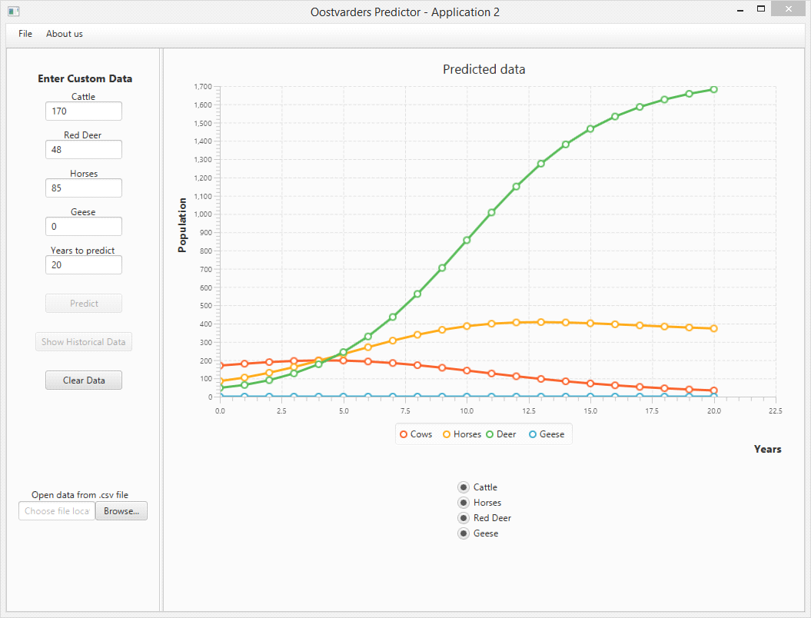

After running several tests with the formula of the competitive Lotka-Volterra model together with new introduced variable G (Grass), several results were discovered. On one hand, the result was showing that cows are reaching adjacent to extinction, after about twenty years from the prediction date. On the other hand, the deer population is reproducing at a much greater speed than any other herbivore. In the first five years, the deer reproduce slower, however, after those five years, they start to take over the area of the nature preserve. This means that after fifteen years the deer population becomes four times greater than the first five years. Unlike the two herbivores, the horses start to decline downwards after a period of thirteen years. One of the only things the application itself can’t predict is the weather effects, such as cold winter/warm summer, on the herbivores. Therefore, the accuracy of this application is sufficient for this research’s purpose.

4.3 Result Software Development

To implement all the information that is collected the **software development** is done in both frontend development and backend development, with Java and JavaFX. With the intention of showing predictions in a graph, which’s outcome is based on the input that will be inputted by the user.

Due to the dynamic built of the application the best choice for creating the *front-end work,* or the GUI, was by utilizing Scene Builder. The GUI is designed to be a simple yet effective interface. It consists of Menu Bar, Text Fields, Buttons, Radio Buttons and Graph, which visually displays the data. The GUI of the application can be seen in Figure 2.

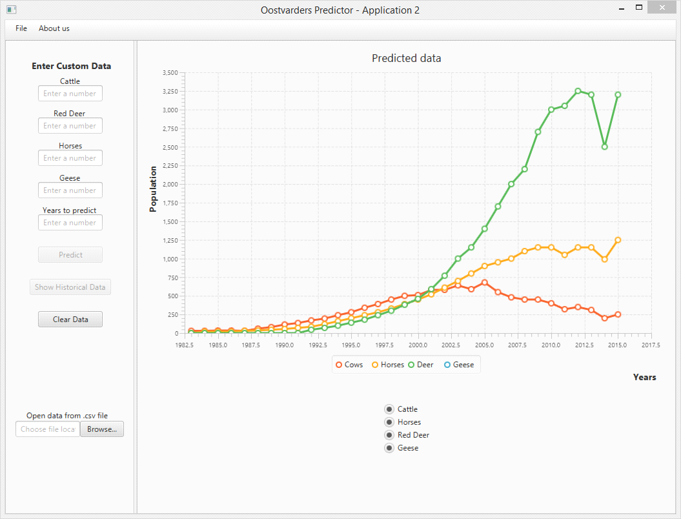

Inside the *Menu Bar,* three main items can be found. A primary item is the close functionality, which allows the user to exit the application, and is found under “File -> Close”. Another item is in “About us”, which opens a window with a brief introduction about the application creators.

“Cattle”, “Red Deer”, “Horses”, “Geese” and “Years” are the *Text Fields* which prompt the user to enter Custom Data, numerical values specifically, that will be used in the Prediction model. The fields are checked by application for correct entry; if the user enters a word value instead of a numerical one, or leaves area empty – an error message will be displayed.

The predominant *buttons*, for the application, are the ones which influence the most the outcome of a prediction. “Predict” is one of the buttons, and its task to take entered data and sends it to Model to execute calculation, then display results in View. In addition to the prediction, the “Predict” Button would also print a message to the console about the grass availability at the end of the calculation. A second button is “Show Historical Data”, which draws the chart of historical data for cattle, horses and deer from 1982 to 2015. The last button resets the Text Fields and Graph view so that the user can renter data for a new prediction, entitled “Clear Data”.

The main purpose of the *Radio Buttons* is to manipulate the chart view. The user can select to display one or more preferred animal graphs or use “Totals” button to show all graphs together.

Since the application displays its results visually, by drawing charts which then will be compared and analysed by the user, the *Graph View* takes up the largest part of the application window. The chart will automatically adjust its scale to given timeframe and graphs. Each animal is assigned a unique colour for better readability.

The *backend work* implemented on the software side is developed in Java code. By using classes and methods, which are referred to by name and invoked at any point in a program to get a functionality. Below can be found a brief description of the main classes and methods that make the application functional.

Following are descriptors of the class used in the package, fund under Application entitled Model, with the most important aspects. The class is the Competition Class, this class will handle all the predictions*.*

It is composed of a general constructor entitled *Competition (),* and has initial data the following parameters: nCows (The initial number of cows), nDeer (The initial number of Deer), nHorses (The initial number of Horses), and nGeese (The initial number of Geese).

One of the methods used in this class is*PredictPopulations(),* this method will calculate the competition of the animals. A next method used is *getMap(),* which returns a map containing the year as a key-value and values. An instance of an output for this method can be found in Example 1.

Method *GenerateJson()* generates a JSON object to be sent to the other application. Example 2 shows an instance of the format.

The method *parseDataReceived(String s)* takes a string in a json format and takes the data out and applies it to relevant variables that needs to be updated. A simple example is: When application one sends the Grass and Geese amounts application two updates the Grass and Geese variables.

The View package, located inside the Application, contains one of the most important classes the Controller Class. This class makes possible the connection between the backend work and the frontend work.

The method *HandleClearData(),* clears the LineChart and the Series Objects, the Series objects contain the points to make up each line drawn. It checks if clearData has been button has been armed if so, un-disables compute and showHistory buttons.

Then follows methods which in essence do similar tasks but for different types. They are the *handleApperanceCattle(), handleAppearanceGoose(), handleApperanceHorse(),* and *handleApperanceRedDeer.* All these methods remove the Series (Object that contains cords for a specific animal line) from the chart if the radio button is not selected. As well as has the option to add them back if it is selected again.

The next method is *handleCompute()*, which has several tasks performing init. Firstly it takes numbers from the input and makes them variables. Secondly creates a map to store data, followed by the creation of a Competition object and fills parameters with variables made. Then a loop, initialized from 0 until the year inputted by the user, calls the *predictPopulations()* method inside it and fills the map to store data. Formerly loops through the map and adds the data to a Series (Object that holds information to draw the lines for each animal). Subsequently, the method then disables compute and showHistory buttons. The final steps are printing information, from the data looping (i.e each predicted year), and adds all the Series into the LineChart object.

The *isInputValid()* method checks that the text fields only contains numbers and no other characters. *handleHistoricalData()* is a method which adds historical data to Series Objects then adds those to LineChart. A dialog box is an alert about creators of application, and is activated by the *handleAbout()* method. The *handleExit()* is the method which helps the user to exit the application.

4.4 Result Connection between Application

The **communication** between the two applications is done via the use of sockets, which send JavaScript Object Notation (JSON) objects containing values used in calculating a prediction. The object will be sent, the application will wait until it receives a response from the other application, then the following year’s prediction will commence. The process of sending the JSON object is as follows: firstly one application will be waiting to receive the data, which is the amount of grass and number of geese, from the other application, from group one. Then calculations will kick in to process the new data. Following a new JSON object will be sent with the information to the other application. This information is the amount of Grass, the population of Geese and the YearOfThePrediction, referred to as the iteration. The outcome in the console, which proofs that the connection works, can be found in Diagram 4. This process will repeat until the last year that is predicted is reached. This process will be similar for both applications.

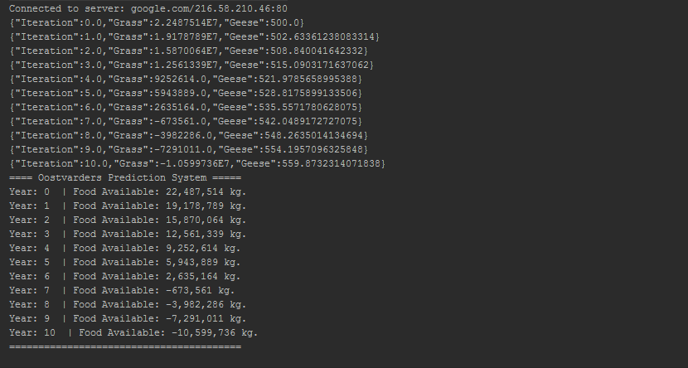The work to implement the connection is handled by backend code, which is inside the Controller Class. One of the methods that handle this task is the*initialize()* method, whichinitializes variables and the connection. While the method *initializeConnection()* initializes the connection to the socket. Another method that is involved, in the process of the communication between the applications, is the *waitUntilResponse*(). This method makes a thread which waits 250ms until it receives an answer from the socket. It will make the program look like it is not responding at times, but this is “normal”.

It is to be noted that the tests for the connection have only been done on the application that this research report has been working on. The address that the application had connected to was "[www.google.com](http://www.google.com/)" as a means to show that the application could connect to a server (Diagram 4). At the time of writing the application has the functionality of receiving and sending data. It will throw errors (Diagram 4.1) if a connection cannot be established to the other application, it will continue to work autonomously otherwise. This, however, will not provide accurate predictions.

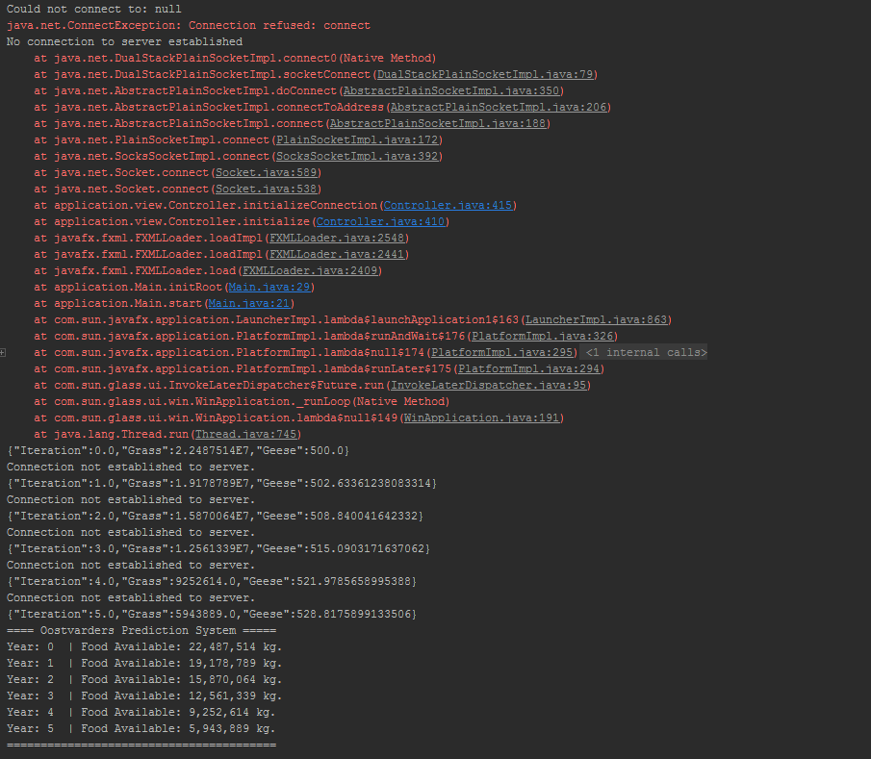

* Conclusion

The Main Research Question for this programme has the focus on two relationships (Section 2.1). On one hand, the relationship for the competition between species, which this paper has been working on. On the other hand, the relationship of pray-predator which the other group, in this programme, have been working on. The Main Research Question for this programme is the following:

*What will happen to the populations of deer, cattle, horse and geese if releasing a number of foxes in the preserve (with the number of foxes being the free variable)?*

Deriving from the programme research question the Main Research Question for this research paper (Section 2.1), at the project level, has in focus the competition between the herbivores. The Main Research Question reads as follows:

*How do the herbivores and the geese compete for the grass in an enclosed area?*

Then, from the Main Research Question, research sub-questions were derived from helping provide the path to the answer of the main question for this research paper (Section 2.2). The research Sub-Questions are the following:

1. *What is the rate of grass consumption of each animal?*

*2. How do animal populations change as a result of grass availability?*

*3. What are the populations of each animal?*

*4. How can the start data and historical data help shape existing mathematical models to an equation which fits the problem in Oostvaardersplassen?*

*5. How can the application hold all the implementations that are being asked?*

The conclusion foe this research paper will be written in the following structure: firstly the sub-questions will be answered, then the Main Research Question from the project level will be answered and lastly the Main Research Question for the programme level will be answered.

The **first sub-question** is referring to the gathering of information about the *grass consumption* of each animal. The way, in which the answer to this question will be given, is by looking at the research done to find out about the amount of grass each of the animals in Oostvaardersplassen needs for survival living. Under the Section 3.2, of the research report, such data can be found.

The grass consumption was introduced as a new variable into the mathematical model. This was due to see the effect of the grass on the herbivores living there. The equation for the calculations, done to deduce the total grass consumption for each animal can be found in section 3.2.

It was deduced, from calculations that the food consumption of the *Red Deer* is at 2.5kg of Dry Matter each day. Konik Horse, on the other hand, have a higher amount of food consumption. Having the average horse consuming every day an amount of 9.4kg of DM each day. However, the highest amounts of food consumptions can be found Cattle, due to the fact that each cow consumes 15kg of DM on average every day. The results and more details of the calculations are under section 4.1.

In order to deduce the impact of the availability of grass on the animal's population sizes, research was conducted to find the formula that most fit the situation. This will lead to an answer to the **second sub-question.**

To test the effect of how animal populations change, because of grass availability, the application needs to confirm that all the parameters have been given. Then the system will use the formula to predict each year, protracted until there is no available grass to be consumed. The application will draw a graph of the effect of the grass availability on the herbivores, showing the effect on the population over years if there is available grass to consume. Therefore, the application will not continue the prediction for the rest of the years where there is no available grass to consume by the herbivores. Which means that starvation will be reached by the animals. The accuracy of the formula had successful testing outcomes. It managed to fill the expectancies of reality in comparison to the historical data. The tests and their results are to be found in Section 4.1 of the research paper.

The general conclusion that can be drawn, from this research, is that after about twenty years, from now, the cows in Oostvaardersplassen will reach extinction. Per the prediction, the cows reach their peak point after seven years, and from that point, they decline downwards towards extinction. Another conclusion is directly related to the deer’s population. The deer will keep populate if they can, and if the will not be grass an issue in this competition. In relation to the graph, the deer population can reproduce in twenty years by thirty-four times. This means that the deer can reach its peak point after twenty years. In contrast to the deer population, when it comes to the horses, the result shows that the horses are reaching their peak point after thirteen years from the prediction day. That point insinuates a slight declining in the population size each year, but extinction will not be reached.

The way in which the **third sub-question** is answered is by the research done to determine the existing numbers of herbivores and geese in Oostvaardersplassen, from the given resources and the information from the Oostvaardersplassen website. The population’s amounts of the herbivores were referenced per 2015. After the research, with calculations and some small assumption, it is now known what the estimated herbivores numbers in accordance to 2016.

It has been found that approximate the population size of cows is 230, which are currently living in Oostvardersplassen preservation. The results found for the population of horses are that 1120 horses are living in the conservation. Lastly, the Red deer population is counted to be deer a numeral of 2930 deer. More information can be found in Section 4.1.

In the **fourth sub-question**, historical data of Oostvaardersplassen had to be accessed. As well as mathematical models, which fitted to find a part of the answer to the problem this research attempts to answer (Section 3.2).

The research for the mathematical model had as a focal pointthe equations of the grass growth. The mathematical model, which was used in the application, is a modified version of the competitive Lotka-Volterra model. The grass is a new variable that was introduced into the mathematical model to measures the grass availability. (Section 3.2) Once the parameters for the finite mathematical models were chosen, existing data was used to gather information about all the variables; so that calculations can be done.

The existing population numbers and total births rates as well as deaths rates,for each of the three-herbivore species from Oostvaardersplassen, were deduced by using given resources. (Section 3.1) However, the data had to be worked with in calculations, in order to get the variables used in the mathematical model. (Section 3.2) Other variables, use in the model, involved more research into finding data about the species that live in Oostvaardersplassen.

The last variable, the competition coefficient, in the mathematical model used a separate equation. Here the data about a species’ dietary distribution was found, which in turn calculated for the grass amount*;* or for the new variable in the mathematical equation.

The implementation for the application with all the information that is collected, for the **fifth sub-question** the use of both front-end development and backend development (Section 4.3), as well as a connection between applications ( Section 4.4). Considering the intention of the application is to be able to show graphs that hold predictions, which are based on the input that will be inputted by the user.

By the use of the UML diagrams and models, found in Section 3.3, the software development had a steady progress. The application has been structured so that a user can input data into the User-Interface, and change it to their liking. A class called competition handles the predications and the communication to the other group’s system. The competition class calculates a prediction using mathematical models, waits to retrieve information on the number of geese and grass from the other Group’s application system. Then does calculations with the new values, sends a message to the other Group’s system, formerly saves the data and repeats the process until it has calculated the amount of years issued by the user. The data is then sent back to the UI to be drawn in a graph for the user (Section 4.3 and Section 4.4). One of the UML diagrams, the domain diagram, shows the conceptual classes and how they interact to predict population changes and update the UI (Section 3.3).

In order to answer the **main research question**, **of this project**, it was needed to understand what is necessary for each animal in order to survive in an enclosed ecosystem. It was deduced that for survival all animals must compete for resources. Competition is a struggle for most species in order to survive in an ecosystem with limited resources. The competition in the enclosed area is mainly about resources for food, water, the ability to reproduce and for space. Animals with the best adaptions will be the ones who can compete in the best way. In this case, the Deer is the animal who compete the best way possible in this ecosystem, due to the fact that they are consuming food in places horses and cows aren’t reaching, in addition to the fact that they are afraid of being next to the cows and horses. On the other way, Cows and Horses are sharing the most space and food and other resources due to the fact that they can live together without threat for their lives (In oppose to the deer, which are afraid to be near other animals). The conclusion of this competition is that the animal which will keep reproducing is the Deer, while the Cows will reach starvation at a certain point, due to the fact the Deer, Horse, and Geese are sharing the same food as the Cows. The Geese itself is difficult to predict how he would behave in an enclosed area, due to the fact that they migrate during most of the seasons.

Unfortunately, an answer to the **Main Research Question for this programme** has yet to be found. The reason for this is because the connection between the two applications, which were supposed to determine the outcomes of the relationship for the competition between species and pray-predator. However doe to the lack of communication between the applications, assumptions are to be made to answer the Main Research Question for this programme, on this part of the research which can be found under Section 4.3.

* Discussions

Below is a list of issues with the data collection, followed by the assumptions made for them where needed.

* One of the assumptions was a linear correlation between grass availability and carrying capacity, which may not hold in real-life scenarios.
* The formula for competition coefficients uses percentages of dietary overlap but does not consider differences in the amount of consumption.
* Multiplying the coefficients by the relative consumption amounts to find a more accurate number.
* Using daily Dry Matter intake for relative consumption amounts, so this calculation does not account for the difference in digestive efficiency.
* The model does not account for the separate types of geese.
* By using the three species of geese present and averaged them as one species.
* For all species, the dietary information was not available for the specific region modelled.
* By using the dietary information from other locations.
* Spring data was unavailable for Konik horses,
* Averaging the summer-winter combined since the research displayed seasonal percentages.
* Terminology was not completely consistent
* Categorized was done by using the Konik Horse’s data from descriptions.
* Not being experts in biology errors cannot rule out in dietary descriptions completely.
* The numbers used to calculate the competition coefficient don’t add up to 100% due to rounding.
* The dietary information for the specific types of geese was too difficult to find.
* Thus, the research used dietary information for Greylag and Barheaded geese combined.
* The only available dietary information for geese was limited to the months of November-April
* Finding dietary information for other seasonal periods proved impossible, however, the research uses it anyway.
* The dietary information for Heck Cattle was problematic to find.
* Thus, dietary information for Wild Cattle is used instead.

* Bibliographies

Startpagina Staatsbosbeheer. Het zit in onze natuur. (n.d.). Retrieved November 23, 2016, from <https://www.staatsbosbeheer.nl/>

Gotelli, N. J. (2008). *A Primer of Ecology* (4th ed.). Sunderland, Massachusetts: Sinauer Associates.

Intake requirements. (n.d.). Retrieved January 06, 2017, from <http://deernz.org.nz/deerhub/feeding/feeding-deer/intake-requirements>

Konik (2016). In *Wikipedia*. Retrieved from <https://en.wikipedia.org/wiki/Konik>

SARAH, R. N. (2016). Nutritional requirements of horses - management and nutrition - veterinary manual. Retrieved January 6, 2017, from <http://www.merckvetmanual.com/mvm/management_and_nutrition/nutrition_horses/nutritional_requirements_of_horses.html>

Cattle. (2017). How much grass does a cow eat each day? Retrieved January 6, 2017, from <http://www.answers.com/Q/How_much_grass_does_a_cow_eat_each_day>

E . Joyner, D., N. Jacobson, B., & D. ARTHUR, R. Retrieved January 1, 2017, from Nutritional characteristics of grains fed to Canada Geese, <http://wildfowl.wwt.org.uk/index.php/wildfowl/article/viewFile/773/773>

Schoener, T. (1974). Some Methods for Calculating Competition Coefficients from Resource-Utilization Spectra. *The American Naturalist,* *108*(961), 332-340. Retrieved from <http://www.jstor.org/stable/2459895>

Co, F. G. Sod installation | Fulton, Arkansas | Fulton grass Co. Retrieved January 8, 2017, from <http://www.fultongrass.com/faq>

Mcinnis, Michael L., and Martin Vavra. "Dietary Relationships among Feral Horses, Cattle, and Pronghorn in Southeastern Oregon." *Journal of Range Management*40.1 (1987): 60. Web. < <http://oregonstate.edu/dept/eoarc/sites/default/files/publication/309.pdf> >.

Wieren, Se Van. "Composition and Cell Wall Content of Diets Selected by Roe Deer, Red Deer, Highland Cattle and Konik Ponies." *Annales De Zootechnie* 44.Suppl. 1 (1995): 121. Web. <<http://rcin.org.pl/Content/12794/BI002_2613_Cz-40-2_Acta-T43-nr6-77-94_o.pdf>>.

Cosyns, Eric, Tine Degezelle, Else Demeulenaere, and Maurice Hoffmann. "Feeding Ecology of Konik Horses and Donkeysin Belgian Coastal Dunes and Its Implicationsfor Nature Management." N.p.,(Dec. 2001). Web.<https://www.researchgate.net/publication/242600674_Feeding_ecology_of_Konik_horses_and_donkeys_in_Belgian_coastal_dunes_and_its_implication_for_nature_management >

Middleton, Beth A., and A. G. Van Der Valk. "The Food Habits of Greylag and Barheaded Geese in the Keoladeo National Park, India." *The Food Habits of Greylag and Barheaded Geese in the Keoladeo National Park, India | Middleton | Wildfowl*. N.p., (1986). Web. <[http://wildfowl.wwt.org.uk/index.php/wildfowl/article/view/774 HYPERLINK "http://wildfowl.wwt.org.uk/index.php/wildfowl/article/view/774"](http://wildfowl.wwt.org.uk/index.php/wildfowl/article/view/774%20HYPERLINK%20%22http://wildfowl.wwt.org.uk/index.php/wildfowl/article/view/774%22) >

"How Much Does a Pallet of Sod Weigh?" *Reference*. N.p., n.d. Web. Dec. 2016. [https://www.reference.com/home-garden/much-pallet-sod-weigh-390e9d062e1a93a8#](https://www.reference.com/home-garden/much-pallet-sod-weigh-390e9d062e1a93a8)